
LACK OF ATTACHED TISSUE
During the initial orthodontic exam, your orthodontist will note any areas of gum loss (recession) or thin gums (attachment loss). As orthodontic treatment moves the teeth through the bone, these areas are more prone to gum loss. If gum loss is significant, the orthodontist will refer you to a periodontist for possible periodontal grafting.

What Causes Lack of Attached Tissue?
- Improper Brushing Habits: Aggressive or improper brushing can damage or wear away the gum tissue, leaving less attached gingiva.
- Periodontal Disease: Gum disease (gingivitis and periodontitis) can cause the gums to recede, leading to a loss of attached gingiva.
- Genetics: Some individuals may have naturally thin or insufficient attached gingiva.

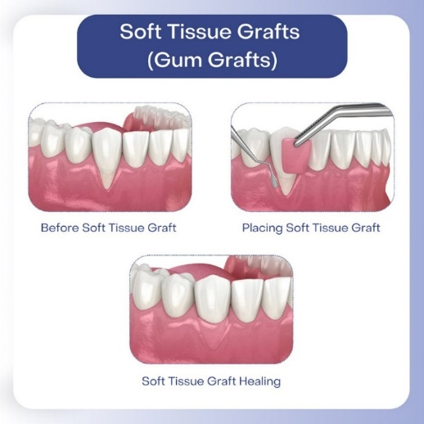
Periodontal grafting is a dental procedure used to treat gum recession or damage to the tissues around your teeth. When the gum tissue around your teeth wears away or recedes, it can expose the tooth roots and make them more vulnerable to infection, sensitivity, and decay. Periodontal grafting helps restore the health of your gums and improve the overall appearance of your smile.

