
Siddhi J. Doshi DDS MS

We would like to perform a procedure called enameloplasty on your child at his/her next visit. Enameloplasty is a procedure in which a small amount of tooth enamel is removed to change a tooth's length or shape. This is purely cosmetic. This does NOT harm the tooth.
.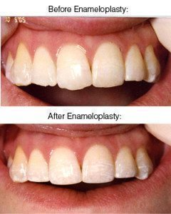
___ Yes, I give permission to perform enameloplasty on my child
___ No, please do not perform enameloplasty on my child
Patient’s name: _____________________________________________
Guardian’s name (print): _______________________________________
Guardian’s signature: ___________________________________________
***Please call (608) 846-3600 or email us at info@greatermadisonortho.com with any questions or concerns***

